VSR Balancing machine
INTEGRALE RACING
CHRA HIGH SPEED BALANCING MACHINE

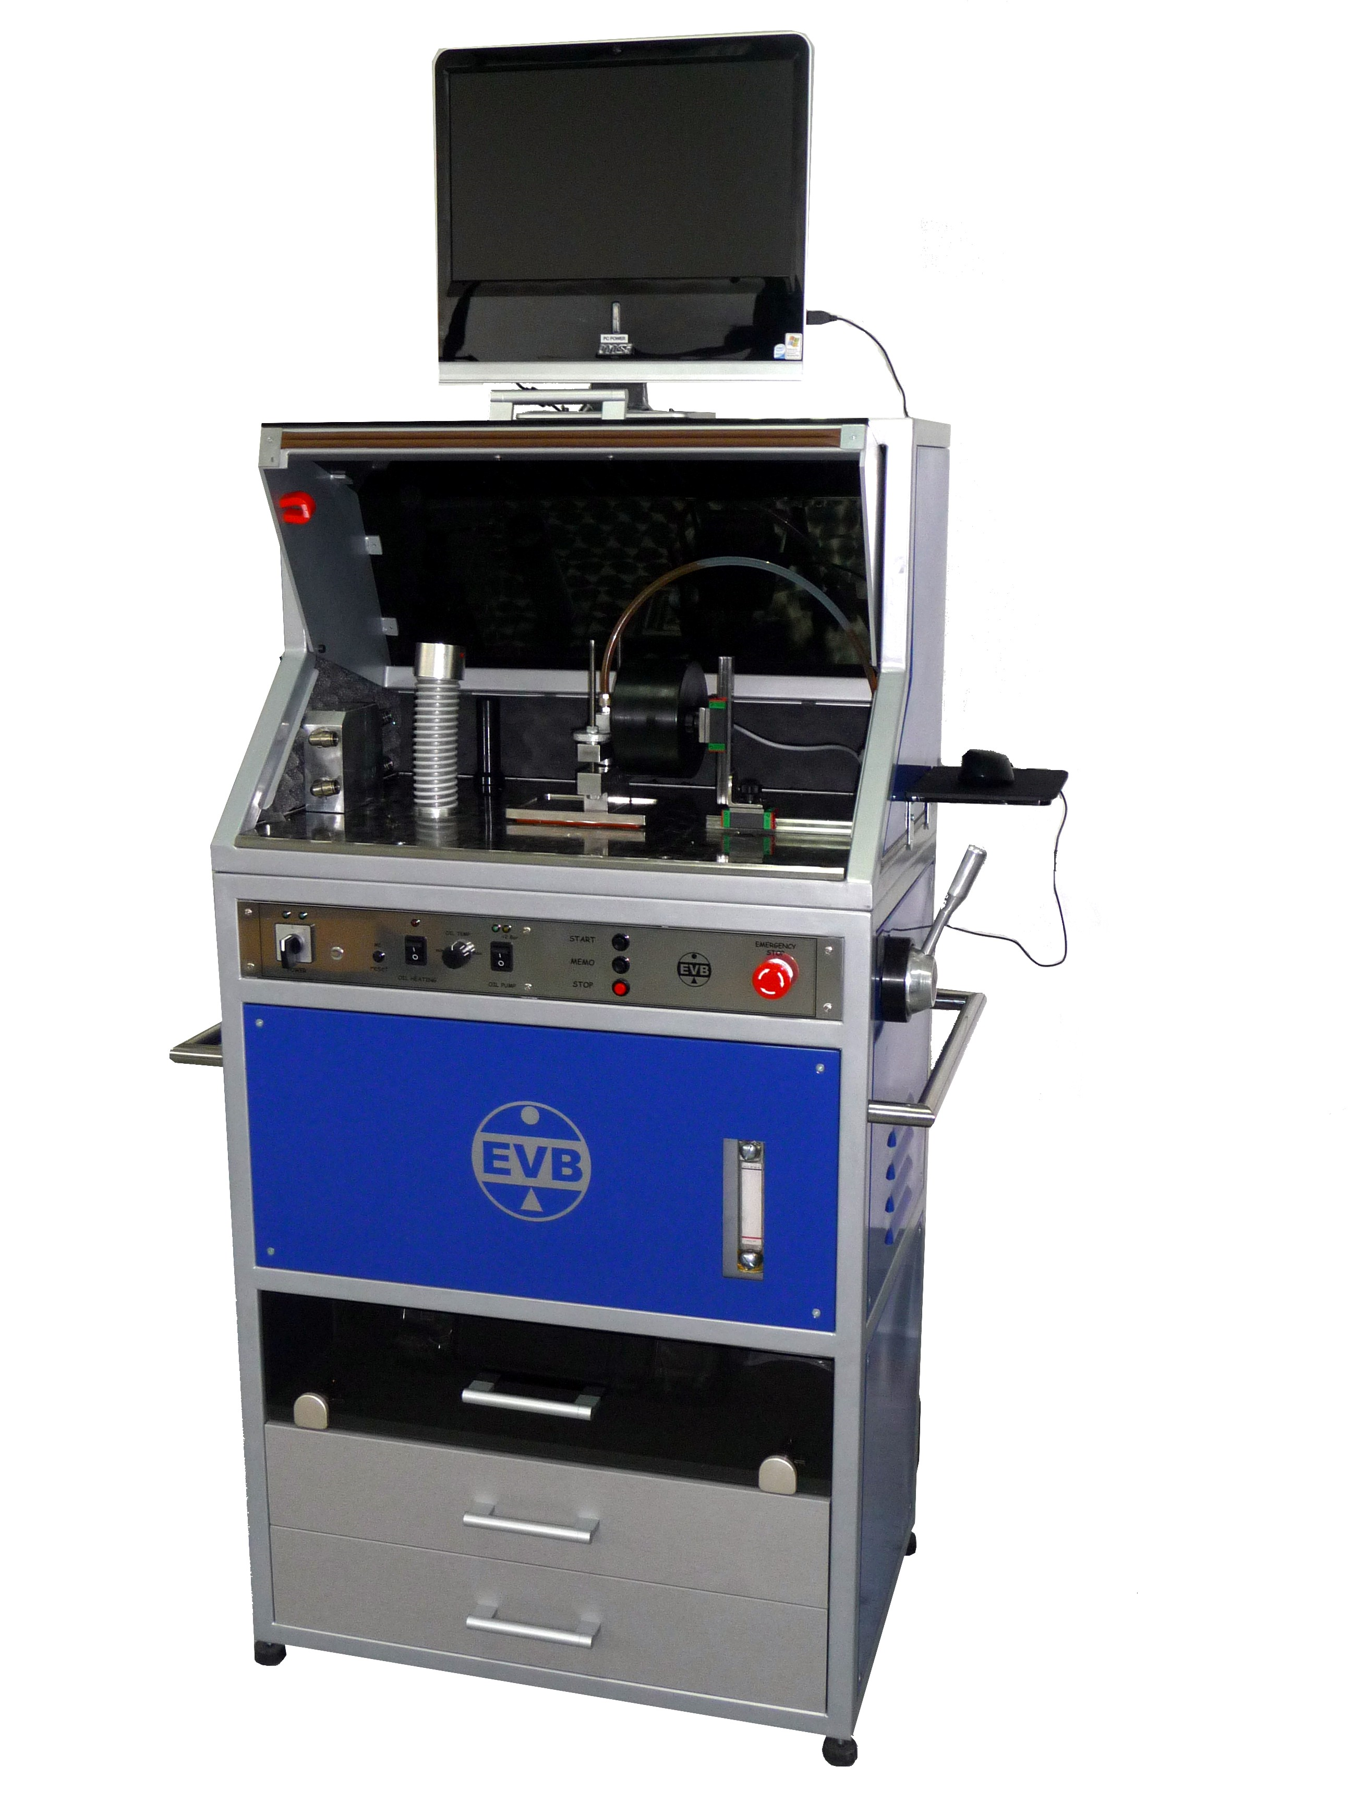

USER MANUAL

TABLE OF CONTENTS

INTRODUCTION 3
GENERAL DESCRIPTION 4
INSTALLATION 5
MAIN MENU 6
APPLICATION SETUP 7
PASSENGER CAR TURBOCHARGER BALANCING 8
BUS-TRUCK-INDUSTRIAL TURBOCHARGER BALANCING 14
PRINT CERTIFICATE 17
MANIPULATING WITH CERTIFICATES 19
UNIVERSAL LANGUAGE MATRIX 21
TECHNICAL DATA 25

INTEGRALE RACING

CORE ASSEMBLY
BALANCING MACHINE

USER MANUAL

INTRODUCTION

Turbocharger rotor core assembly balancing machine type INTEGRALE RACING for VSR high speed balancing.

„User friendly“ concept of construction and application provides high quality balancing of all types of core assembly for passenger cars as well as truck-bus-industrial vehicles (TBI).

In this „USER MANUAL“ there is a detailed description of the machine components and basic instruction for all functions of the machine.

This is unique machine on the international market whitch combines core assembly high speed balancing for passenger cars and truck-bus-industrial vehicles (TBI) and in the same time the oil leakage control with heated oil as the simulation of the turbocharger working condition on the vehicle.

IMPORTANT RECOMMENDATION

FOR THE SUCCESSFUL USE OF INTEGRALE RACING IT IS NECESSARY TO PARTICIPATE IN THE TRAINING COURSE HELD BY OUR SPECIALIST.

THE TRAINING COURSE AND THIS MANUAL PROVIDES COMPLETE VOLUME OF INFORMATION AND SKILLS FOR SUCCESSFUL USE OF INTEGRALE RACING MACHINE.

GENERAL DESCRIPTION

MAIN COMPONENTS

Body of the machine is a steel
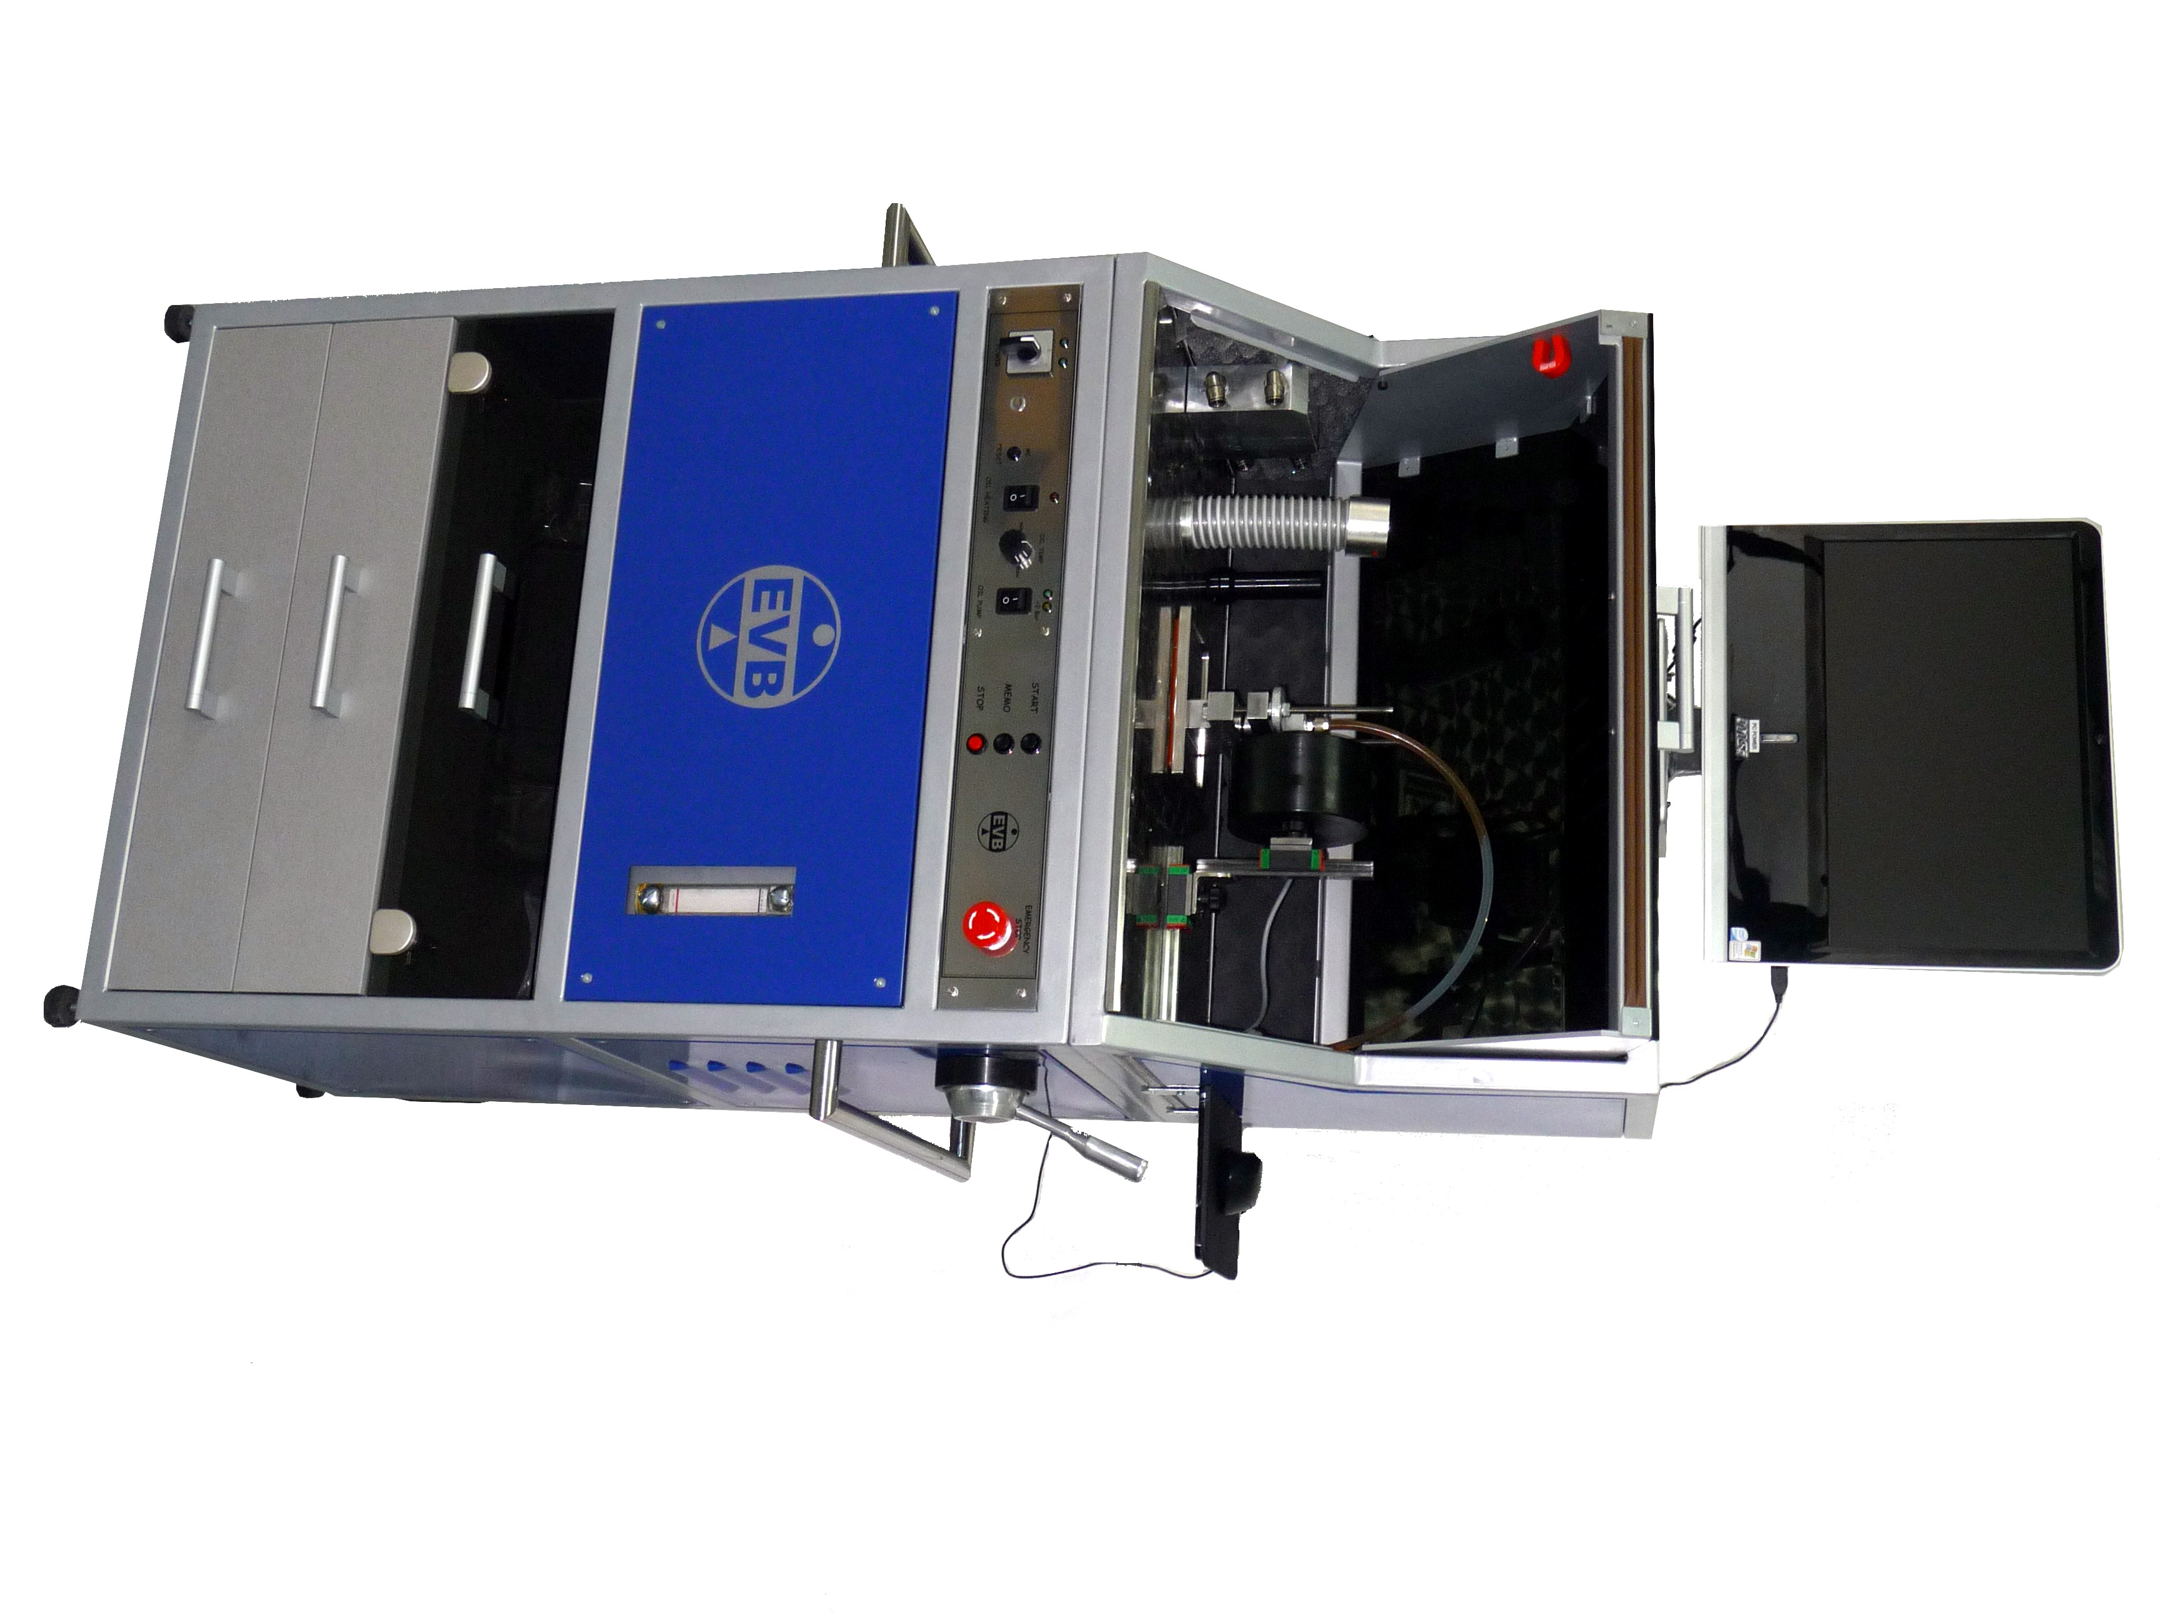
construction divided into three levels.

Upper level of machine body is
working cabin consisting of:
- monitor with all-in-one PC and mouse
- vibration table with piezo electric accelerometer
- air flow system
- oil tube
- magnetic speed sensor
- closing cover

Midium level of machine body
is consisting of:
- command panel with the following functions:
* MAIN switch 0 / 1
* RESET button
* OIL HEATING (switch and regulation)
* oil pump switch
* operation buttons (START, MEMO AND STOP)
* emergency STOP button
- oil tank (4 liter) with heating system
- oil pump (4 bar oil preasure)
- high and low pressure air valve
- electric circuits
- air flow comand handle
- electronic box

Bottom level of machine body is consisting of:
- printer
- storage space for tools

INSTALLATION

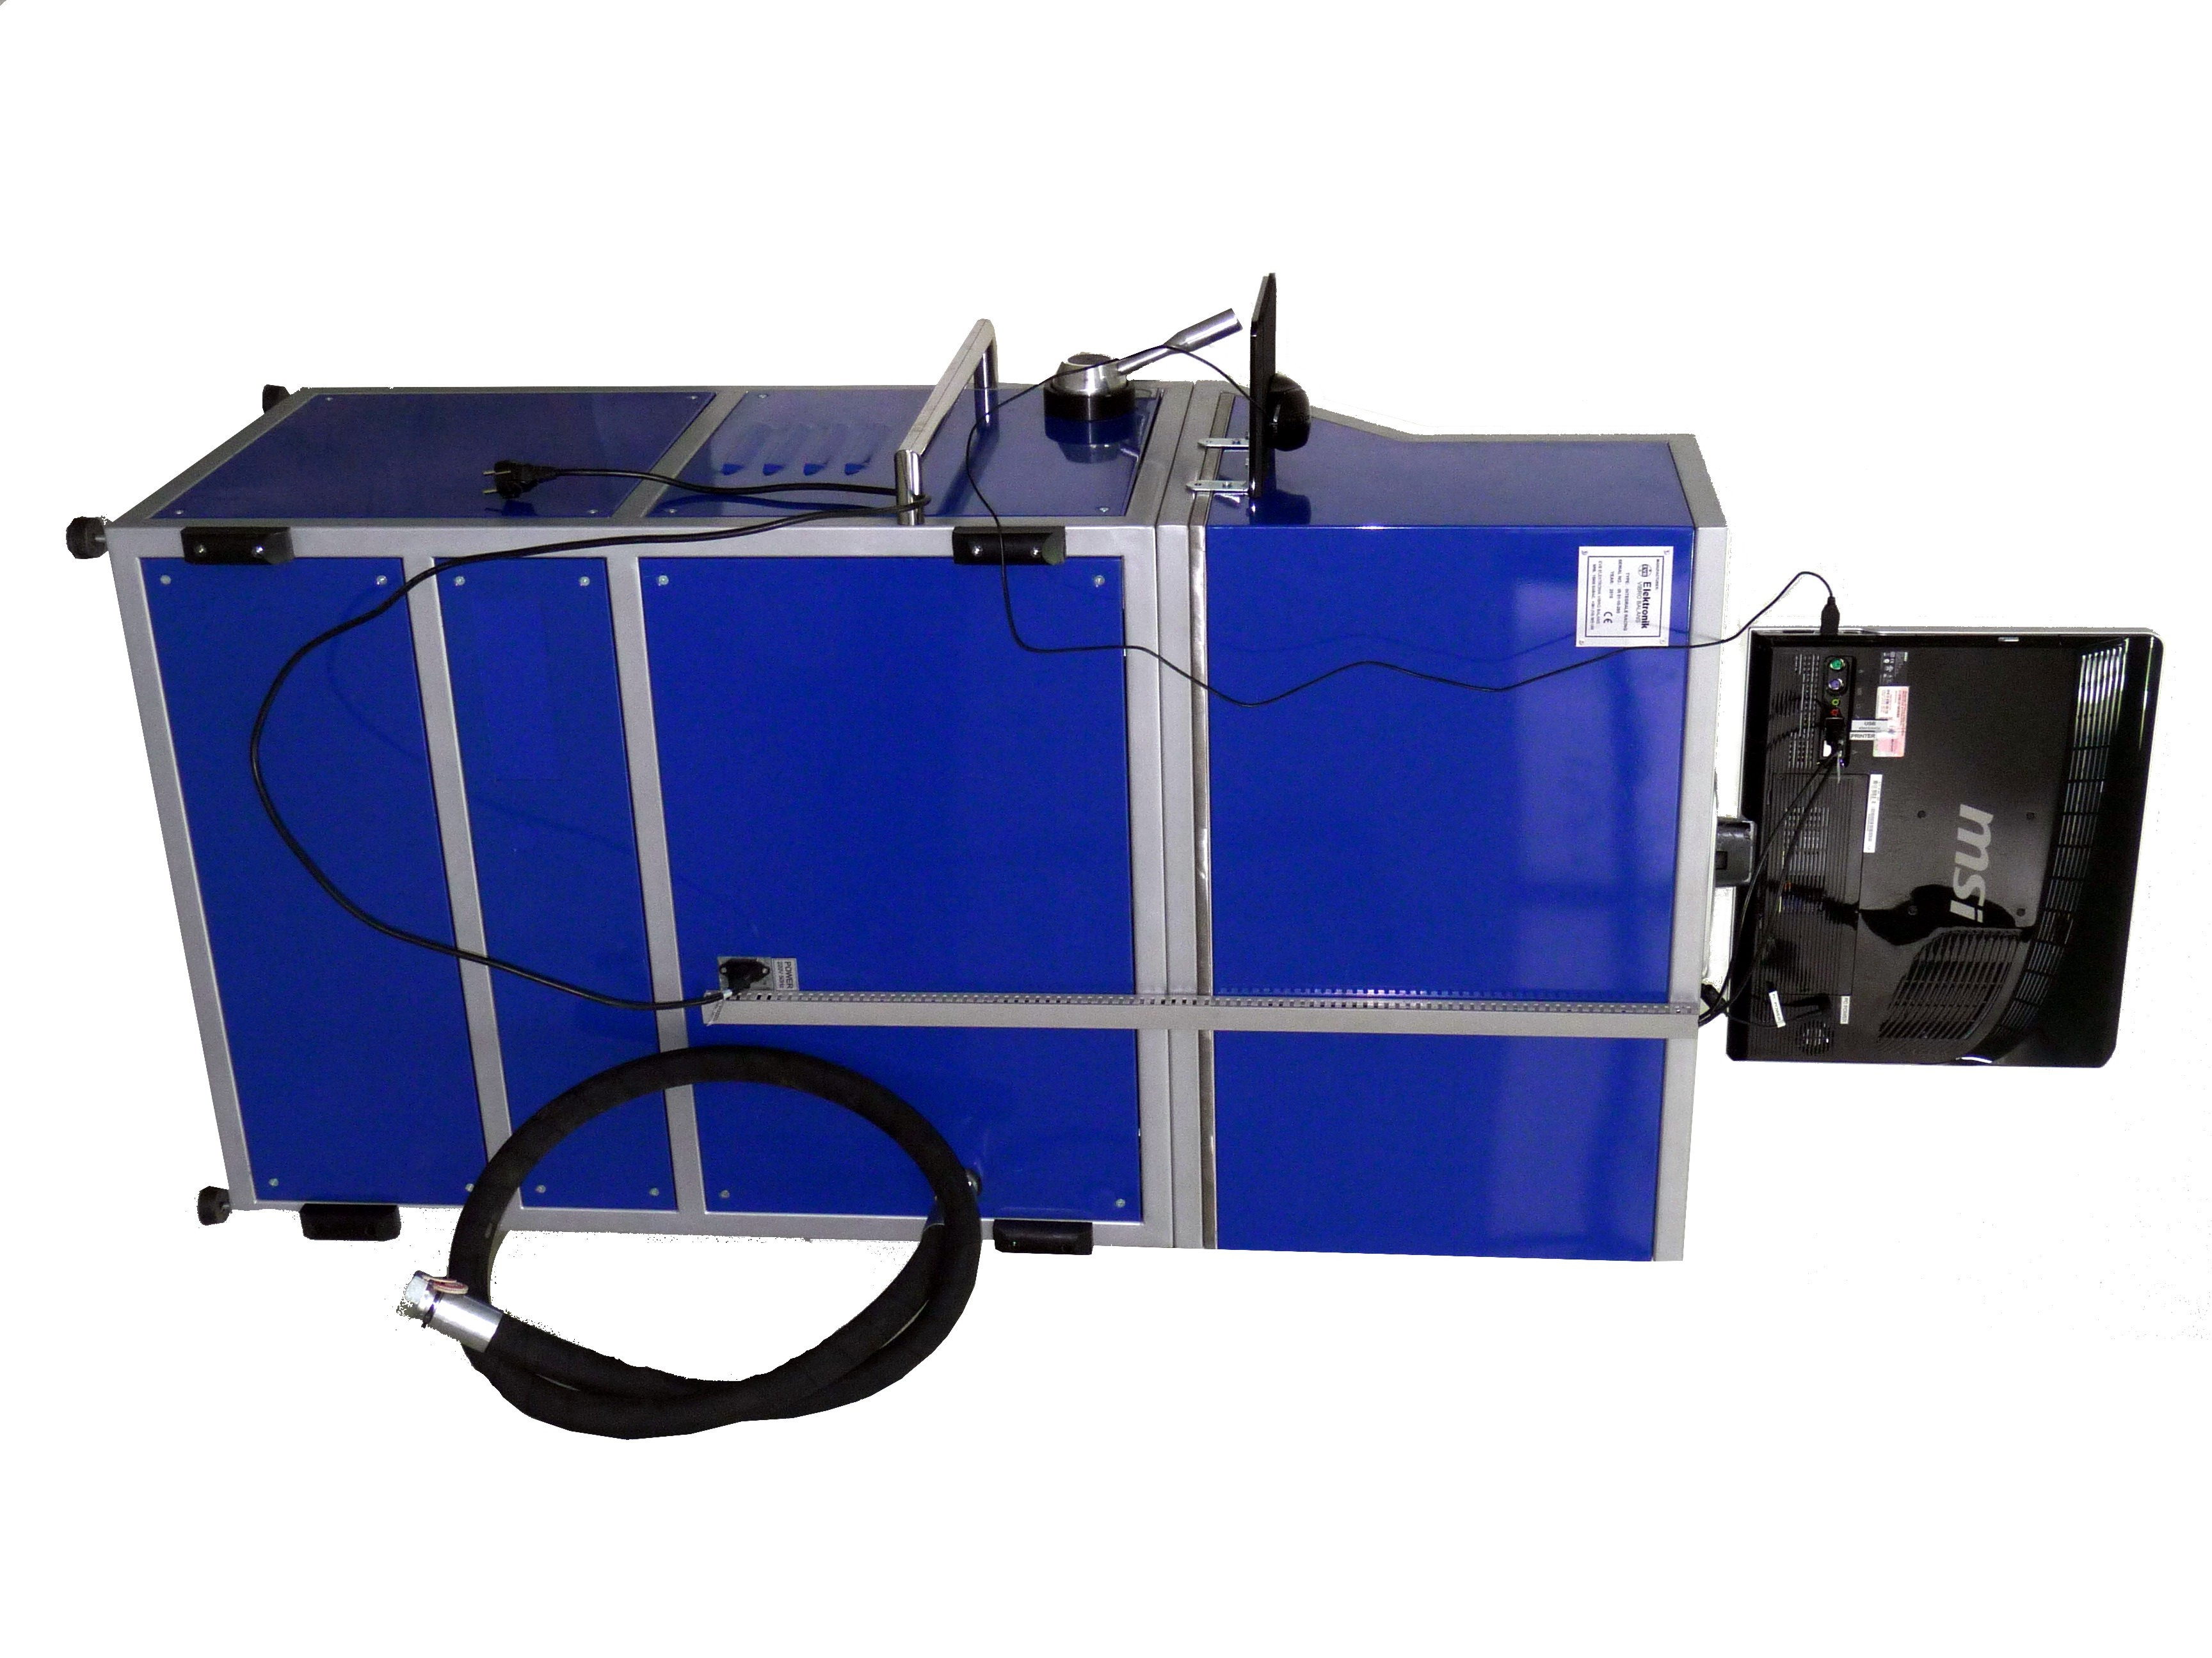

AIR

- 1 inch tube connect with air tank
and air compressor

(500 liter / 900 liters per minute).

ELECTRIC POWER

- machine power connection:
220V / 50 Hz max. 1500 W

Connection between electrical units
to be made according to the labels
on the rear panel.

MECHANICAL INSTALLATION

- four rubber supports to be fixed to
the body of the machine to
achieve stable vertical position.
- fix the airtube
- fix the air comand handle
- fix the mouse plate
- connect the curency cable.

MAIN MENU

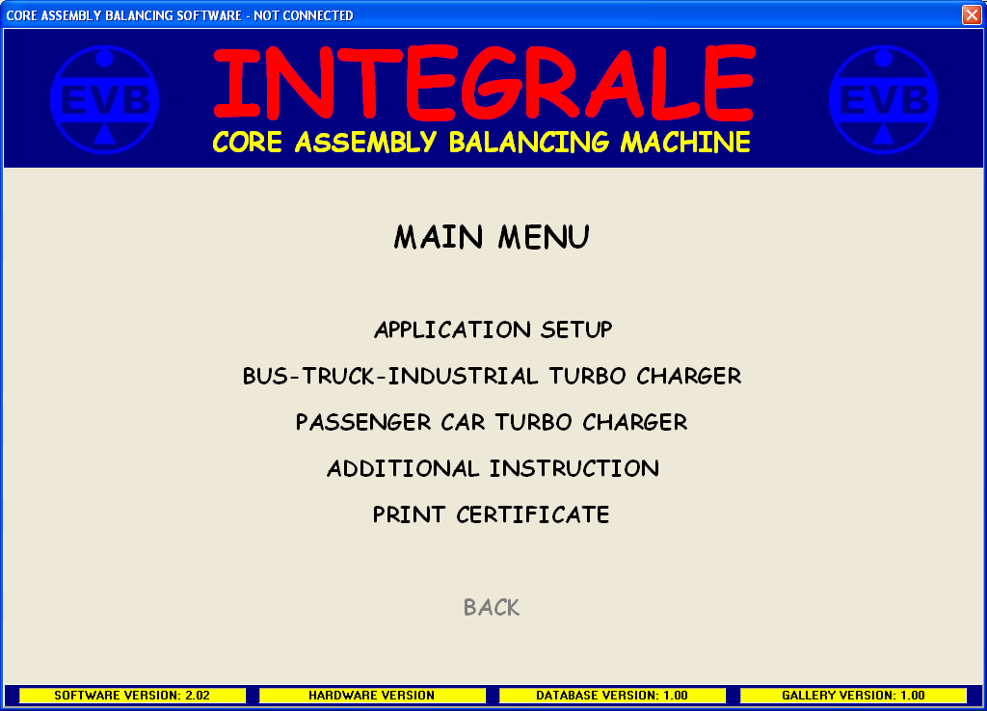

On the dialog above, fundamental functions of machine are listed.

In the following chapters of this USER MANUAL there are details of each function.

The choice of each function is to be made with left button on the mouse.
WARNING
- TURBOCHARGER TEMPERATURE 60 – 80 ºC.
- WHILE BALANCING COMPRESSOR COVER MUST BE ON.
- WHILE BALANCING ROTATION CLOSING COVERAGE MUST BE CLOSED.
- DO NOT TOUCH TURBOCHARGER ROTOR WHILE ROTATING.
APPLICATION SETUP

It is possible to register the Company data in the program of INTEGRALE RACING.

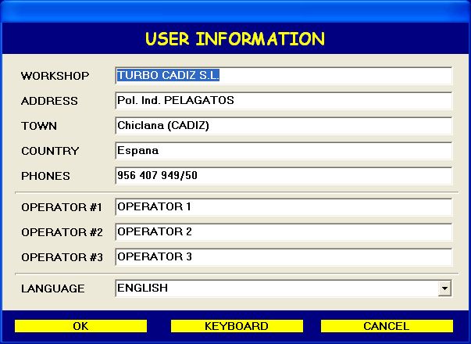

This information appears on the Certificate of Balancing.

The users of INTEGRALE RACING have possibility to choose language of operation.

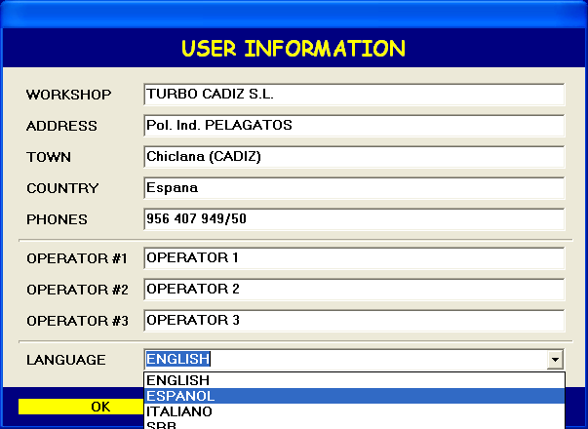

The choice of the language is to be made:
- click on the drop down menu (language section) with left button on the mouse
- select the language
- click OK with left button of the mouse

1. PASSENGER CAR TURBOCHARGER BALANCING

This type of balancing is used for all types of latest generation passenger car turbochargers.

Before mounting the shaft and wheel into the core assembly, the dynamic balancing of shaft and wheel with compressor wheel on the rotor balancing machine should be executed with the quality (tolerance), 1-2 milligrams residual unbalance per each side (compressor and turbine wheel). We highly recommend application of EVB REVICON balancing methodology.

In the process of core assembly on the compressor part of the turbocharger rotor apears a certain level of unbalance
(5-10 milligrams) which could be eliminated by PASSENGER CAR TURBOCHARGER balancing on the
INTEGRALE RACING machine.

The following procedure is to be made:

1.1 Turn on power switch.
1.2 Press PC power on.
1.3 Press oil heating on (wait 15 min. for 60 degree celsius temperature).
1.4 Fix the core assembly on the vibration table using proper tools.
1.5 Magnetize the rotor shaft (compressor side) 5-6 times.
1.6 Adjust the rotation speed sensor to rotor shaft (2-4 mm gap).
1.7 Mount the TURBOCHARGER HOUSING on the turbine side and connect with air distribution.
1.8 Close the machine cabin.
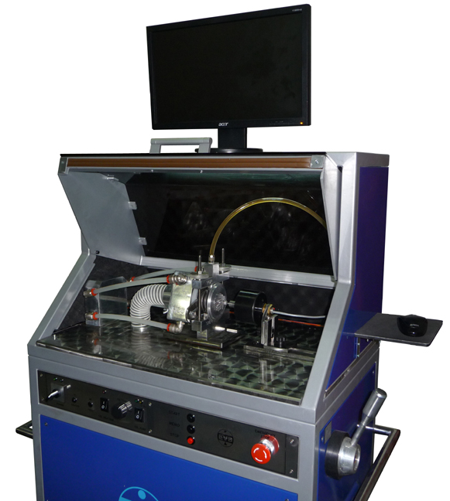
1.9 On the monitor appears main menu.
1.10 With the mouse select PASSENGER CAR TURBOCHARGER section.
1.11 On the monitor appears TURBINE SELECTOR mode.
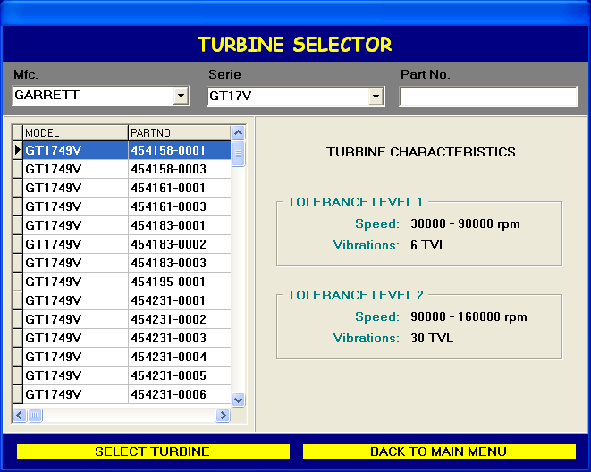
1.12 EVB Standard is special mode in which is possible to select the test speed range for every type of turbocharger.
- To select particular turbocharger (Garrett, KKK, Mitsubishi, IHI, Toyota, ...) click on the Mfc drop down menu.
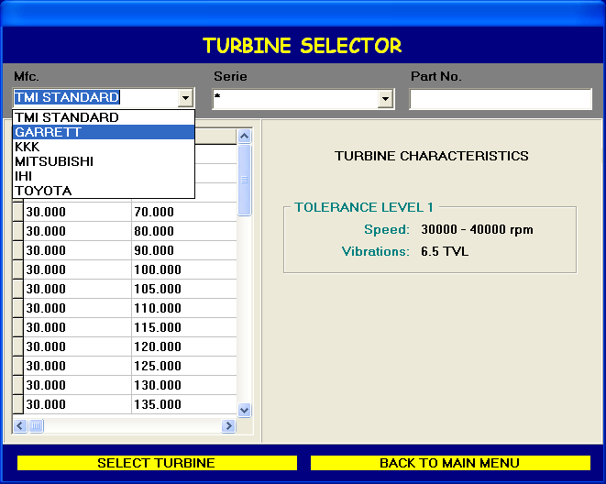
- With the left button on the mouse select the particular turbocharger.
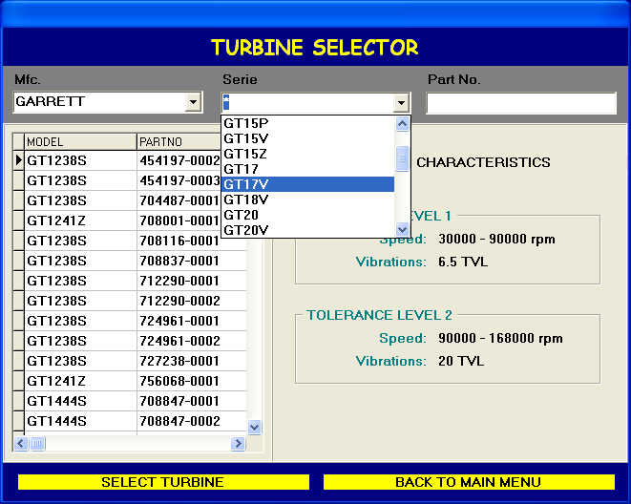
1.13 On the monitor appears PASSENGER CAR TURBOCHARGER instruction.
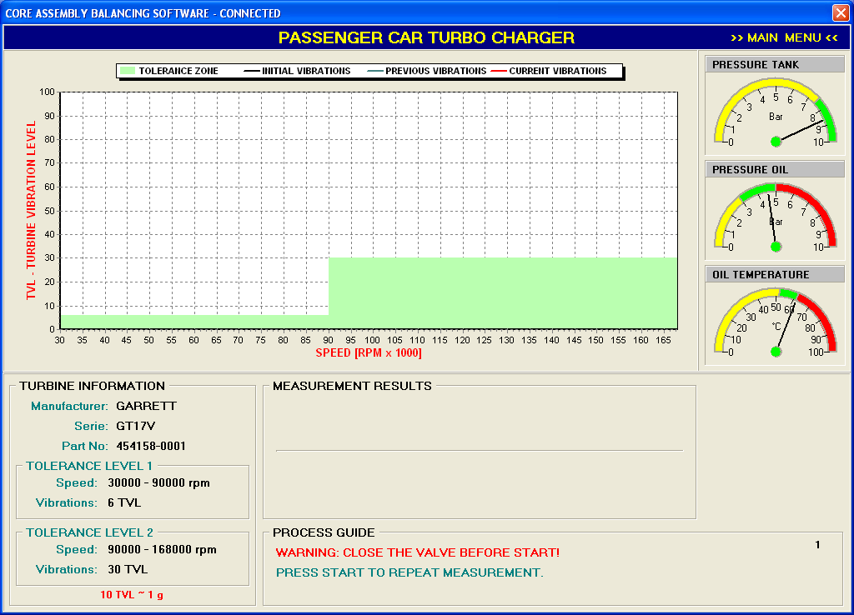
1.14 On the instruments on the right side there are the following indication:
- air tank pressure
- oil pressure
- oil temperature
1.15 In the process giude section there are important instruction to be followed in the proces of balancing.
1.16 Press START button on the control panel to continue the process.

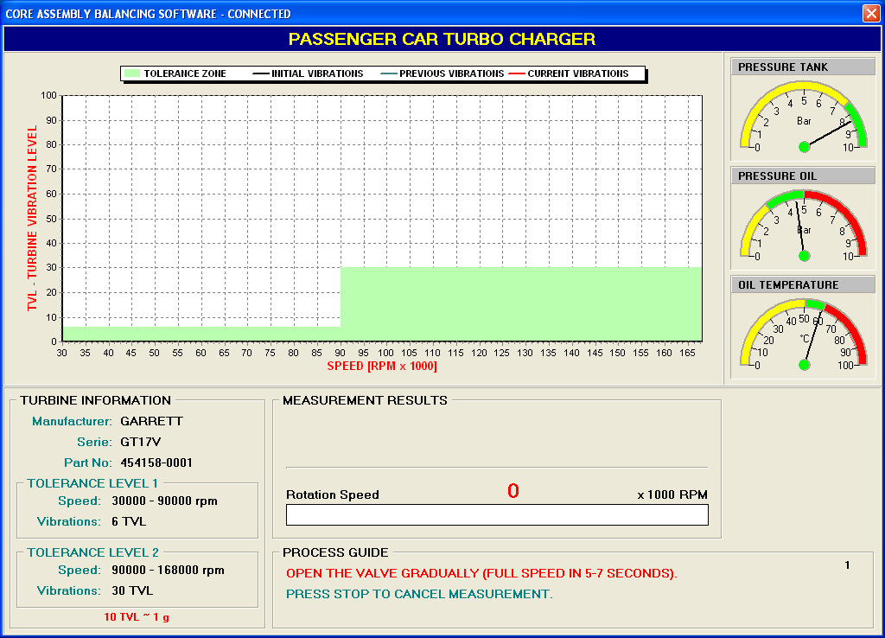
1.17 Pull the air handle for the air control to the maximum rotation.
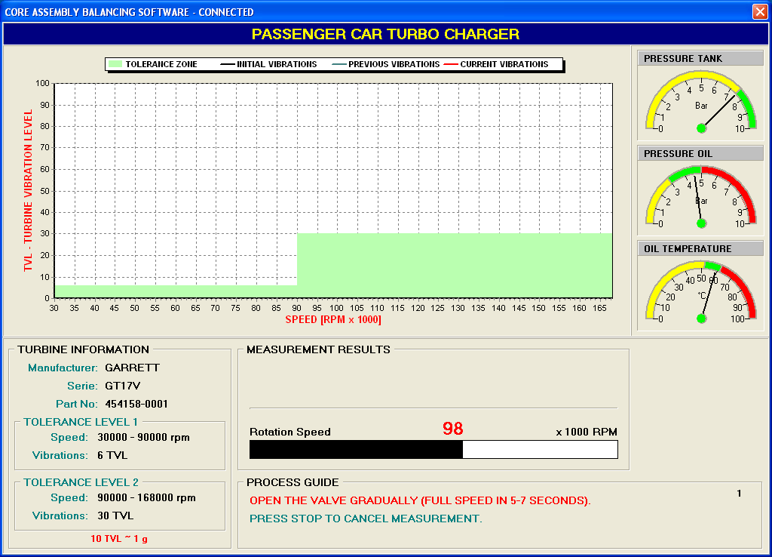

1.18 The result or measurement is presented on the next illustration.
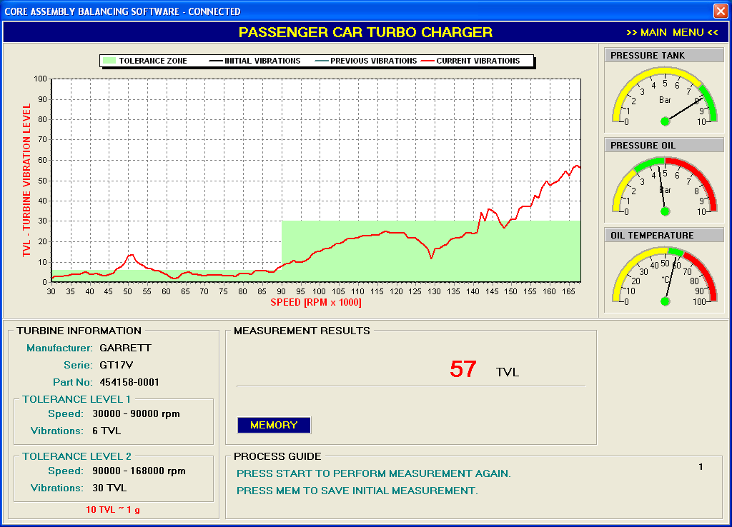
The line in the green field represent the turbocharger vibrations in frequency acceleration domain.
- The unit of turbocharger vibration level is called TVL.
- In case the turbocharger vibration level exceed the level of green field (tolerance level) the core assembly
has to be balanced on the compressor side.

1.19 OIL LEAKAGE CONTROL

It is recommended to perform oil leakage control before starting the procedure of balancing.

After the turbocharger reconditioning process it is very important to be sure that the oil leakage does not appear.

- Oil temperature 60 – 80 ºC recommended
- Select EVB Standard, turbocharger 30.000 – 35.000 rpm
- Press START and accelerate the core assembly between 2.000 and 4.000 rpm and keep 30 seconds.
- Press STOP.
- Visual oil leakage control
- Press START and accelerate the core assembly to 35.000 rpm (repeat several times).
- Visual oil leakage control.

If no evidence of oil leakage the process of balancing should be continued.

1.20. PROCEDURE OF BALANCING

- INITIAL MEASUREMENT

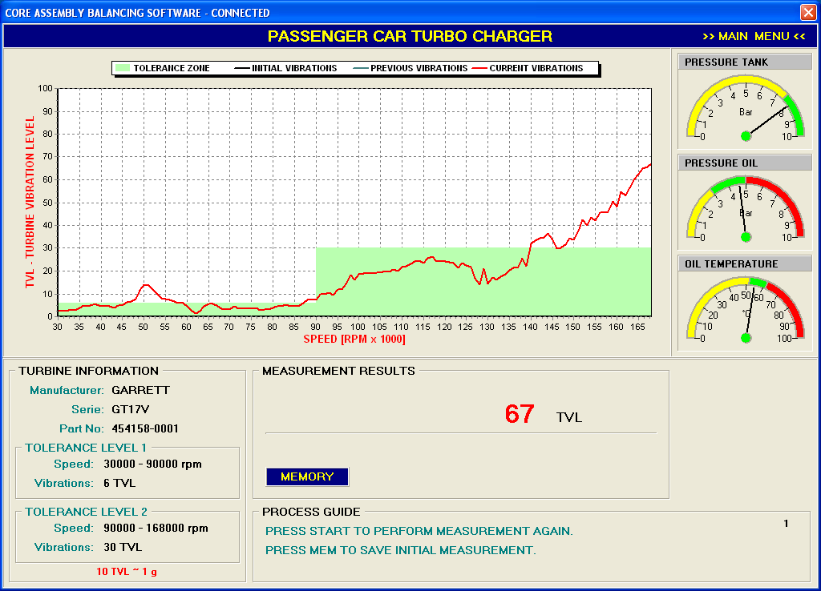

Analisys:

- The vibration level is out of tolerance
- The procedure of balancing should be continued

- CALIBRATION PROCESS

- Press MEM on control panel to save the measurement data of initial measurement
- Grind 2-3 milligrams from the compressor side
- Calibration position is point zero (0 degree), red line on the yellow circle.
- Perform the measurement again.
- Results:

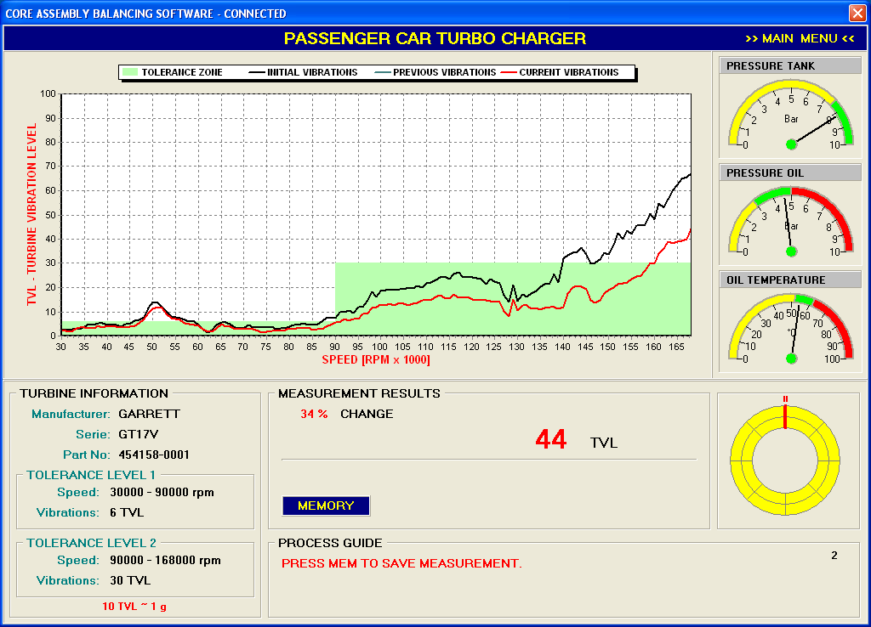

Change has to be over 20 percent (if not - try again; if yes – press MEM on the control panel).

- FINAL BALANCING (CORRECTION PROCESS)

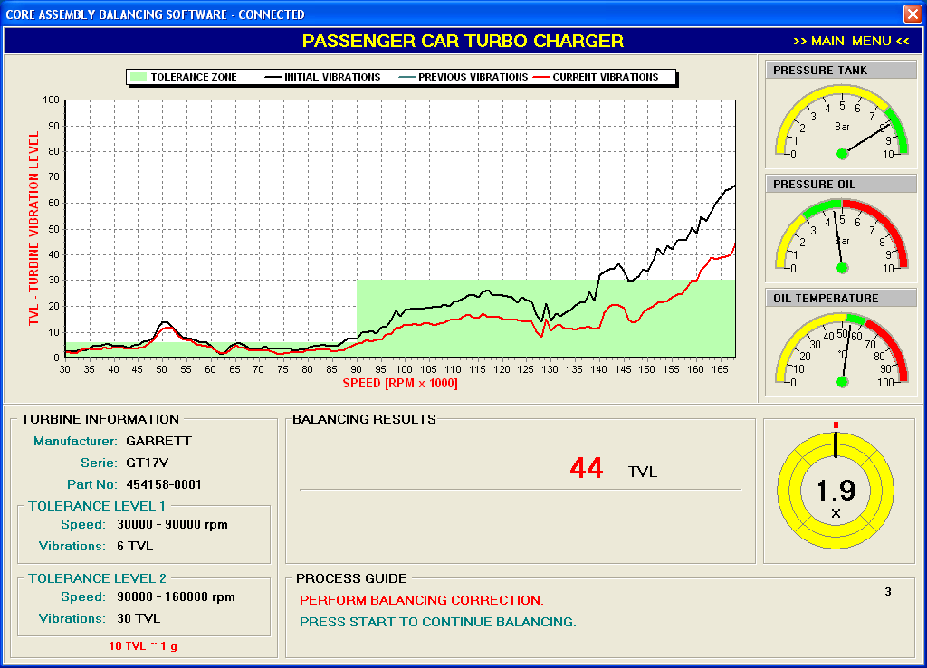

Instruction for correction (balancing) – Angle:

- Position of correction (angle) – black line on the yellow circle.

Instruction for correction (balancing) – Magnitude:

- On the black line position grind 1.9 times calibrated level

- FINAL TEST

Perform new measurement.

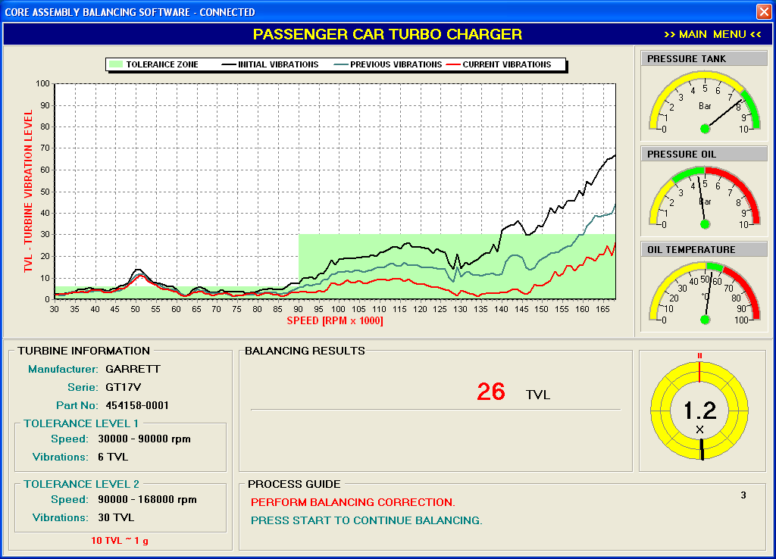

- The final vibration level is in tolerance field (green field).
- The balancing is finished.

2. BUS-TRUCK-INDUSTRIAL TURBOCHARGER BALANCING

Before mounting the shaft and wheel into the core assembly, the dynamic balancing of shaft and wheel with compressor wheel on the rotor balancing machine should be executed with the quality (tolerance), 1-10 milligrams residual unbalance per each side (compressor and turbocharger wheel).

In the process of core assembly on the compressor part of the turbocharger rotor apears a certain level of unbalance
(10-50 milligrams) which could be eliminated by BUS-TRUCK-INDUSTRIAL TURBOCHARGER balancing on the
INTEGRALE RACING machine.

2.1. UNIVERSAL HOUSING

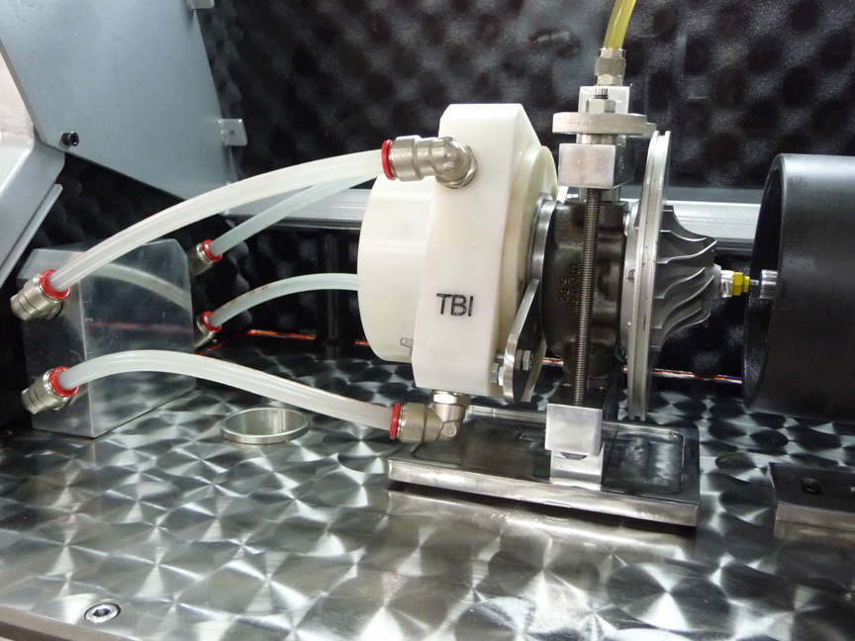

On the photo above it is presented BTI core assembly fixed on the vibration table of the INTEGRALE RACING, conneced with oil tube and universal housing fixed on the core assembly and connected with equivalent air tubes.

2.2. For additional visual information use ADDITIONAL INSTRUCTION in MAIN MENU.

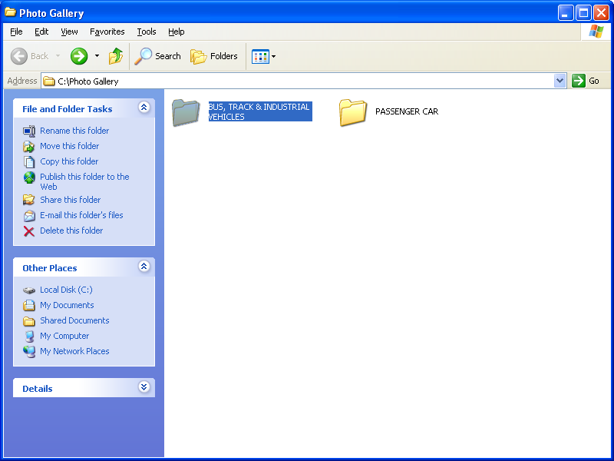
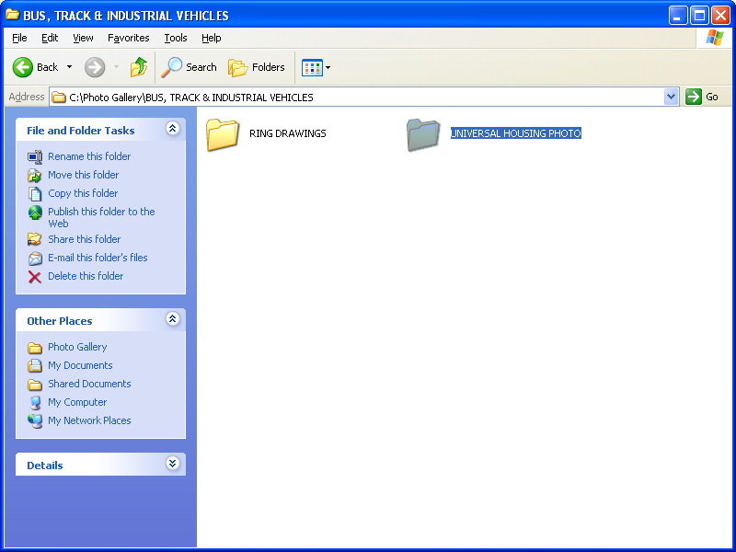
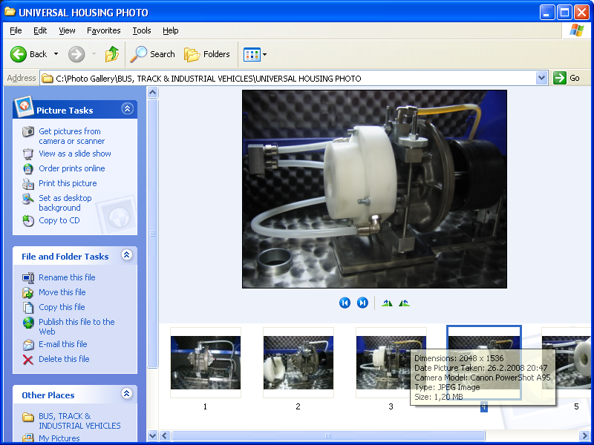
→ ADDITIONAL INSTRUCTION
→ BUS, TRACK & INDUSTRIAL VEHICLES
→ UNIVERSAL HOUSING PHOTO
2.3. For additional technical information regarding the RING DRAWINGS use
ADDITIONAL INSTRUCTION in MAIN MENU.

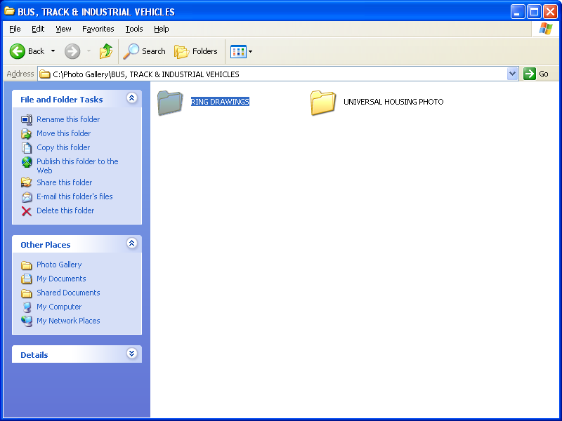

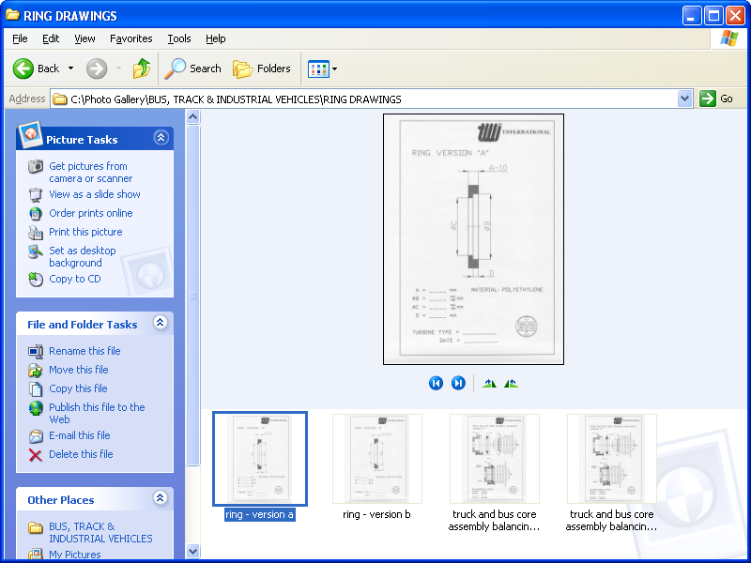

→ ADDITIONAL INSTRUCTION
→ BUS, TRACK & INDUSTRIAL VEHICLES
→ RING DRAWINGS

2.4. Oil Leakage Control (same as point 1.20)

2.5. PROCESS OF BALANCING (BTI - Turbochargers)

2.5.1. In MAIN MENU select BUS-TRUCK-INDUSTRIAL TURBOCHARGER.

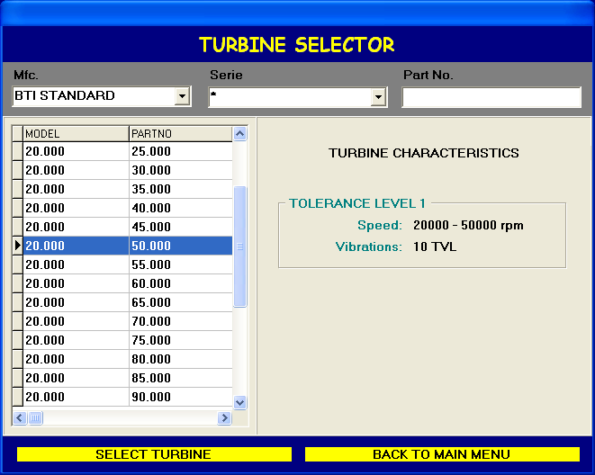

2.5.2. After BTI selection appears (TURBINE SELECTOR):

2.5.3. Select the maximum speed for the particular turbocharger testing from lower to higher speed.

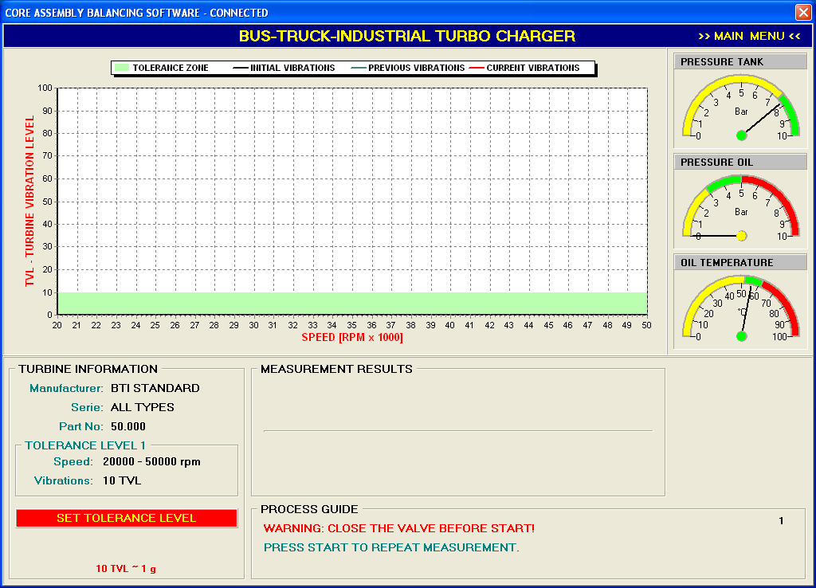

2.5.4. The process of balancing is equivalent to the process of balancing passenger car turbocharger.

PRINT CERTIFICATE

1.) PRINTER INSTALLATION

Based on the installation instruction of printer device.

2.) CERTIFICATE CONFIGURATION

1. In the MAIN MENU select APPLICATION SETUP

2. Insert the data in USER INFORMATION dialog

3. Select OK to save data

3.) PRINT CERTIFICATE (DATA OF FINISHED BALANCING)

1. From the MAIN MENU select PRINT CERTIFICATE

2. Complete the certificate data (operator and client data)

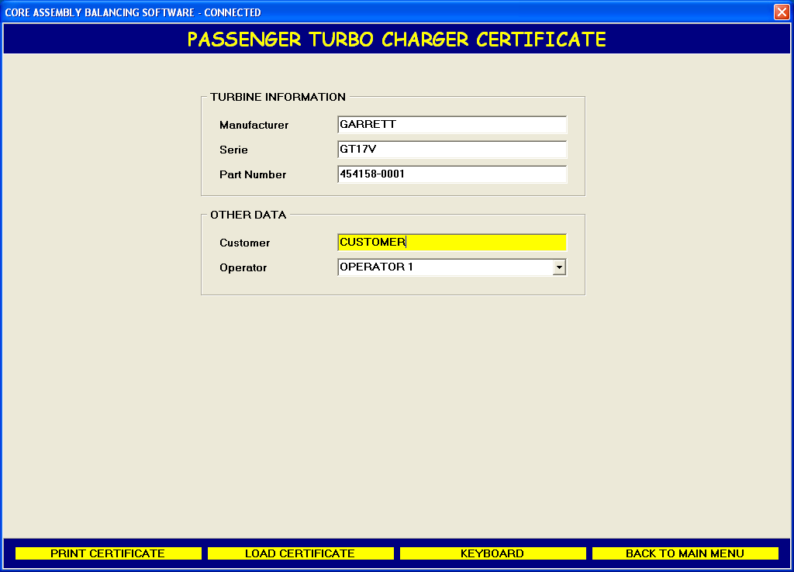

3. Select PRINT

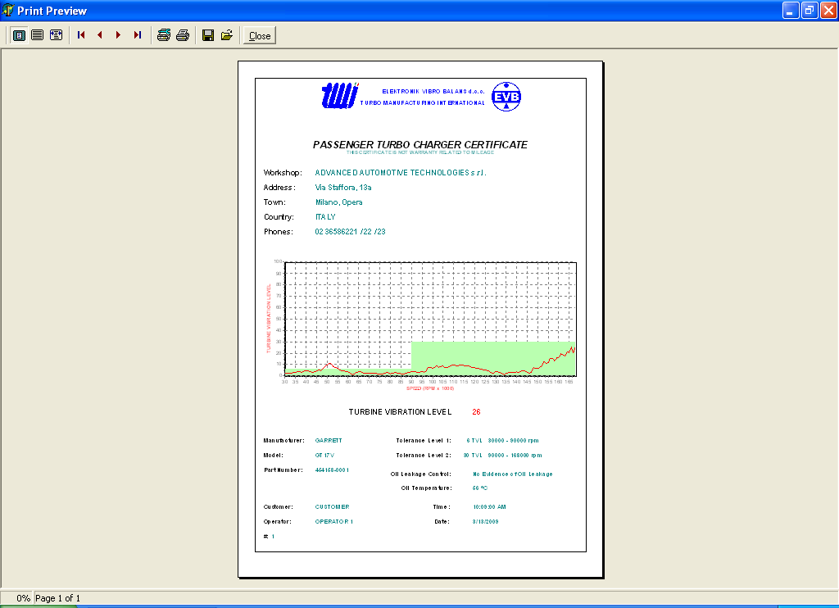
MANIPULATING WITH CERTIFICATES

1.) STORING DATA ON LOCAL HARD DISC

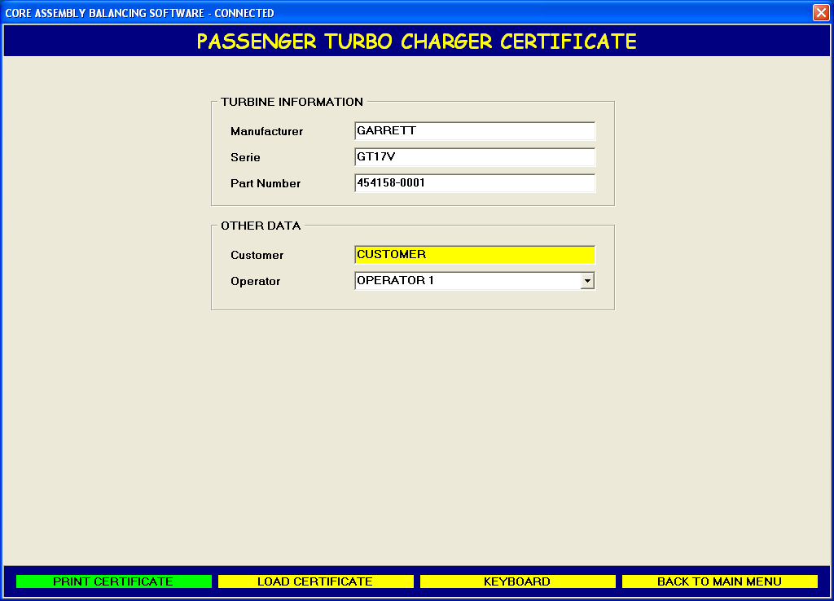

Each time you press button PRINT CERTIFICATE data will be automatically stored on hard disc in following format:

customer ddmmyyyy-hhmmss.qrp

dd – day

mm – month

yyyy – year

hh – hour

mm – minute

ss – second.

2.) READING DATA FROM LOCAL HARD DISC

Reading saved data from local hard disc:

Select LOAD CERTIFICATE

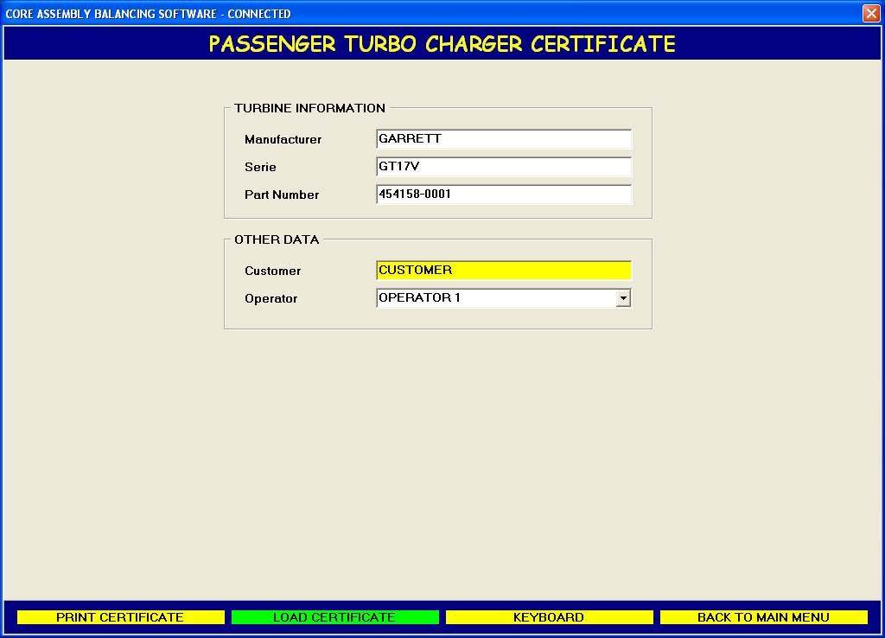

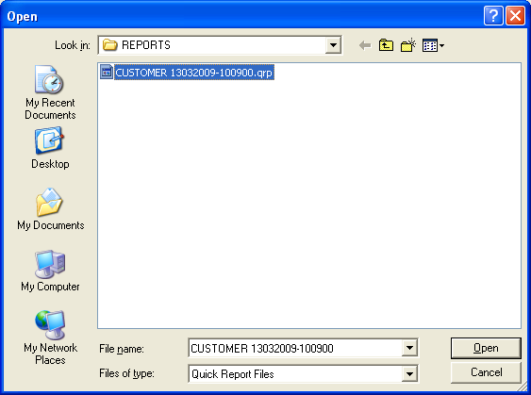
UNIVERSAL LANGUAGE MATRIX

In our ULM system the english language is the basic language.

Please, consider the following steps.

- Press START → All Programs → Accessories → Windows Explorer
- On the Folder section select Local Disk (C:) and open folder INTEGRALE RACING.
- At the INTEGRALE RACING File section double click on file ENGLISH.LNG to open.

- Pick option «Select the program from a list» and press button OK.
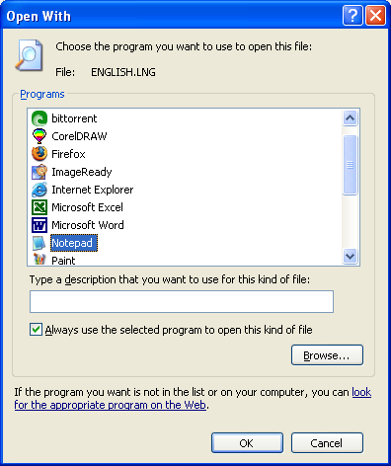
- On the dialog above, choose the program «NotePad» to open the «ENGLISH.LNG».
- Check option «Always use the selected program to open this kind of file».
- To open file press button OK.
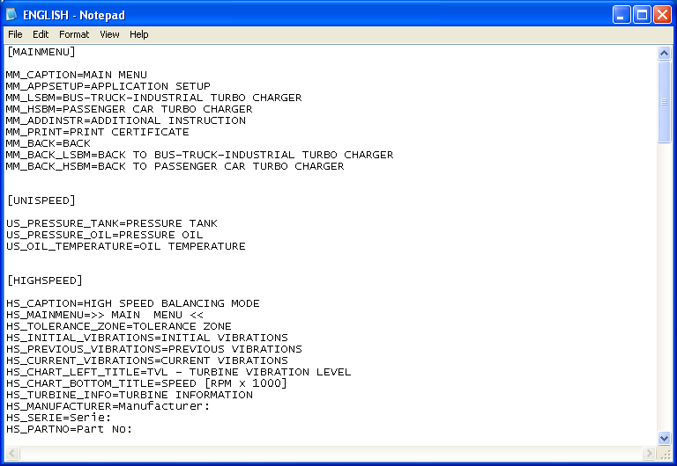

- Important Notes
* ONLY MAY BE TRANSLATED TEXT AFTER SIGN «EQUAL».
* TEXT IN BRACKET MUST NOT BE TRANSLATED.
* TEXT BEFORE SIGN «EQUAL» MUST NOT BE TRANSLATED.
- After translation is finished you have to save this document with new file name.
- Select Save As... from the File menu.
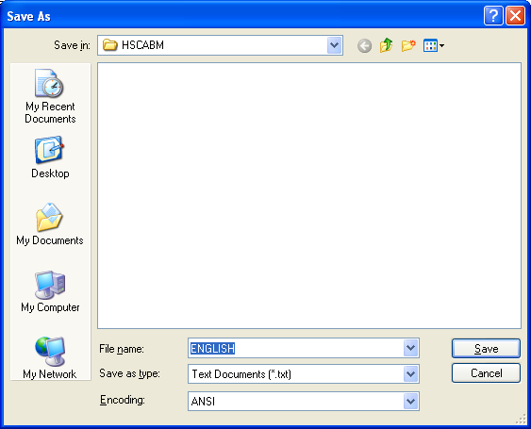
- Change File name from ENGLISH to your language
(GERMANY.LNG, FRANCE.LNG and others).
- Change «Save as type» from «Text Documents (*.txt)» to «All Files».
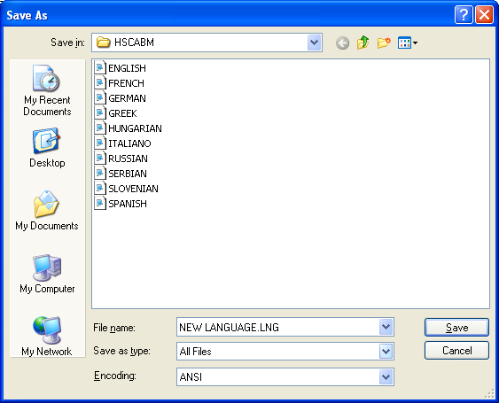
- Press «Save».
- Start program INTEGRALE from the desktop.
- Select option «APPLICATION SETUP»
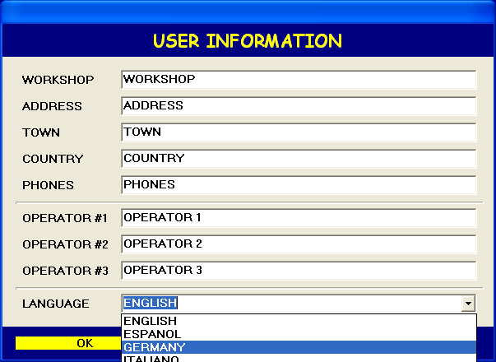
- In the «USER INFORMATION» dialog, change default language to your language.
- Press «OK» to SAVE YOUR LANGUAGE.

TECHNICAL DATA

Type | INTEGRALE RACING 2020
Turbocharger types | Passenger and BTI

Passenger car
Balancing speed  Testing Speed | up to 168.000 rpm  up to 250.000 rpm
Turbine housing adapter | Adapter for each turbocharger type  (standard list)
Core assembly fixing tools | Universal
Balancing method | Semiautomatic calibration  INTEGRALE RACING
Balancing quality (tolerance) | 0 – 2 mg
Unbalance correction | Universal grinding tool

Bus-Truck-Industrial (BTI)
Balancing speed | 30.000 – 100.000
Turbocharger wheel cover | Tool for each turbocharger type
Core assembly fixing tools | Universal
Balancing method | Semiautomatic calibration  INTEGRALE RACING
Balancing quality (tolerance) | 0 – 10 mg
Unbalance correction | Universal grinding tool

Dimensions
Height | 1880 mm
Width | 900 mm
Length | 650 mm
Weight | 200 kg

COMPRESSED AIR
Pressure | 8 – 10 bar
Connection tube | 1 inch / 2 m length
Capacity | Max. 1000 l / min

ELECTRICAL POWER
Power | 1500 W
Voltage | 220 V / 50 Hz

WARNING
- TURBOCHARGER TEMPERATURE 60 – 80 ºC.
- WHILE BALANCING COMPRESSOR COVER MUST BE ON.
- WHILE BALANCING ROTATION CLOSING COVERAGE MUST BE CLOSED.
- DO NOT TOUCH TURBOCHARGER ROTOR WHILE ROTATING.

STANDARD LIST OF STARTERS

TURBOCHARGER TYPE MODEL

1. GARRETT GT 12
2. GARRETT GT 20
3. GARRETT T02
4. GARRETT T25
5. KKK K03-I
6. KKK K04
7. KKK K14-I
8. KKK K16
9. KKK KP35
10. KKK K26
11. IHI VL20
12. IHI RHB5
13. IHI VA67
14. MITSUBISHI TD02
15. MITSUBISHI TD04
16. MITSUBISHI TD05
17. MITSUBISHI TF35
18. TOYOTA CT20
19. GARRETT GT 15 - 9
20. GARRETT GT 15 - 10
21. GARRETT VNT 17
22. GARRETT VNT 18
23. GARRETT VNT 22
24. KKK KP 39-V

TBI STARTERS

1. UNIVERSAL STARTER
2. RING – K27
3. RING – K32
3. RAW RINGS 3 PIECES
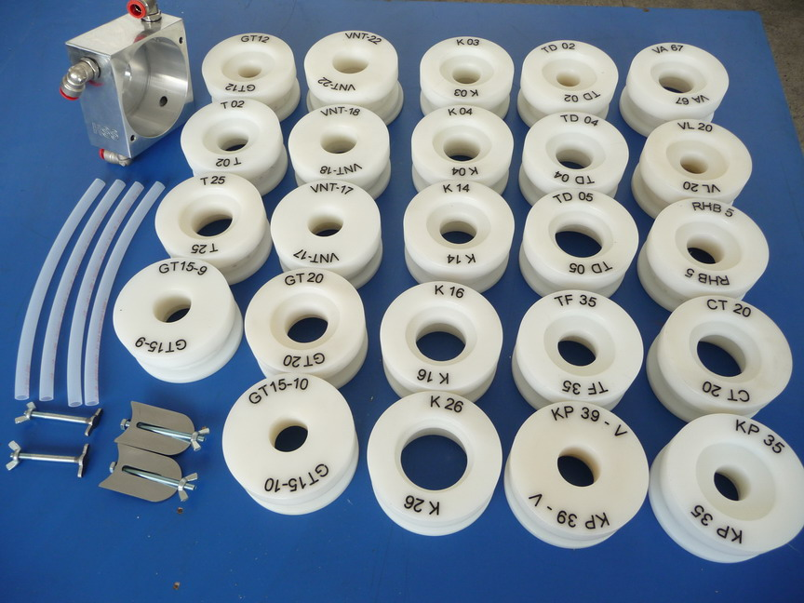

STANDARD STARTERS

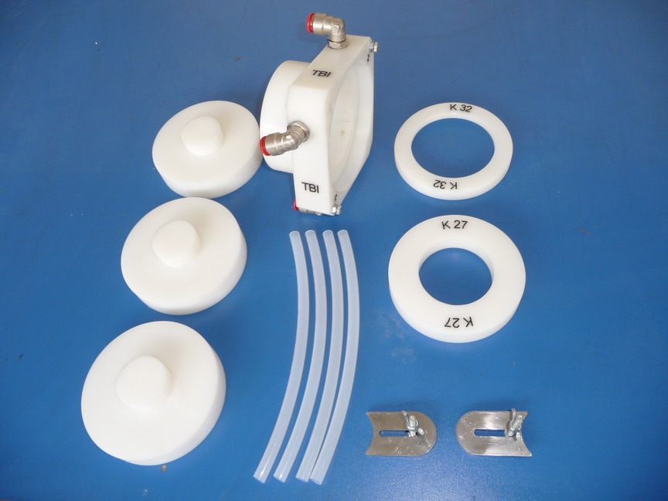

TBI STARTERS
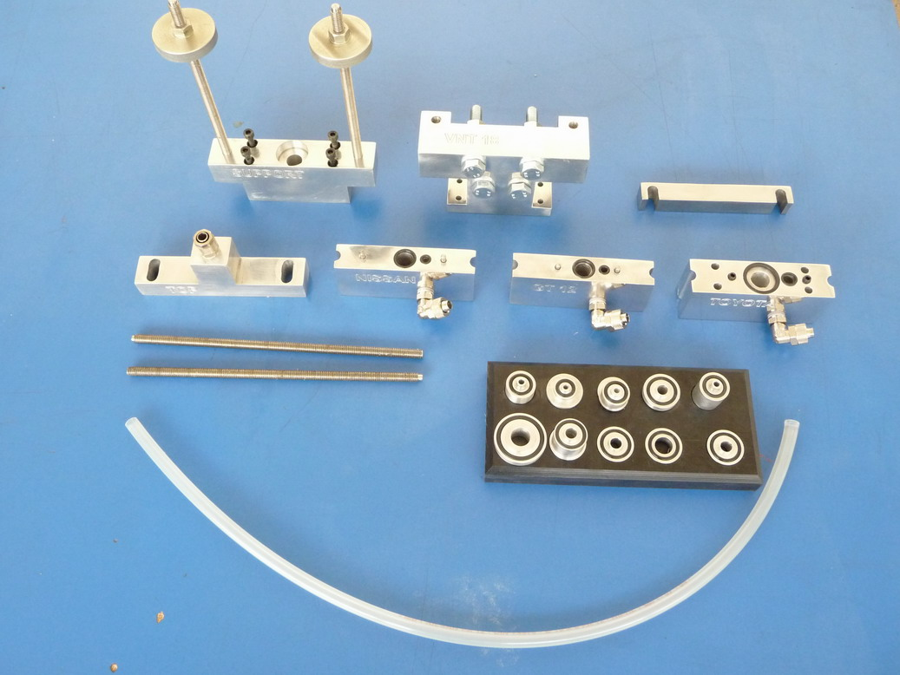

SPECIAL SUPPORTS AND ACCESSORIES FOR TOYOTA, NISSAN, GT 12 I GT 18

WE WISH YOU SUCCESS!

Europe distributor :


Turbo Power Limited
Kozolupy 286
330 32, Kozolupy
Czech Republic
email: info@turbospareparts.eu
www.TurboSpareParts.eu

